**Nathan Weber**

**WDD230**

**July 7, 2022**

**Temple Inn & Suites Site Plan**

**Site Purpose:**

**The purpose is to give each user a clear path to reserve a room near the temple of their choice.**

**There will be 4 pages. The home page’s purpose is to assure the user is in the right place and be exciting enough to help them continue. The temple page is to give them a view of the temples we cater to. The reservation page helps make a reservation. Lastly, the services page shows the user what services we provide, like breakfast, gym, or a pool.**

**Target Audience:**

**My target audience will be church members who need lodging near a temple. These could be regular temple workers or one-off temple tourist.**

**Site Map:**

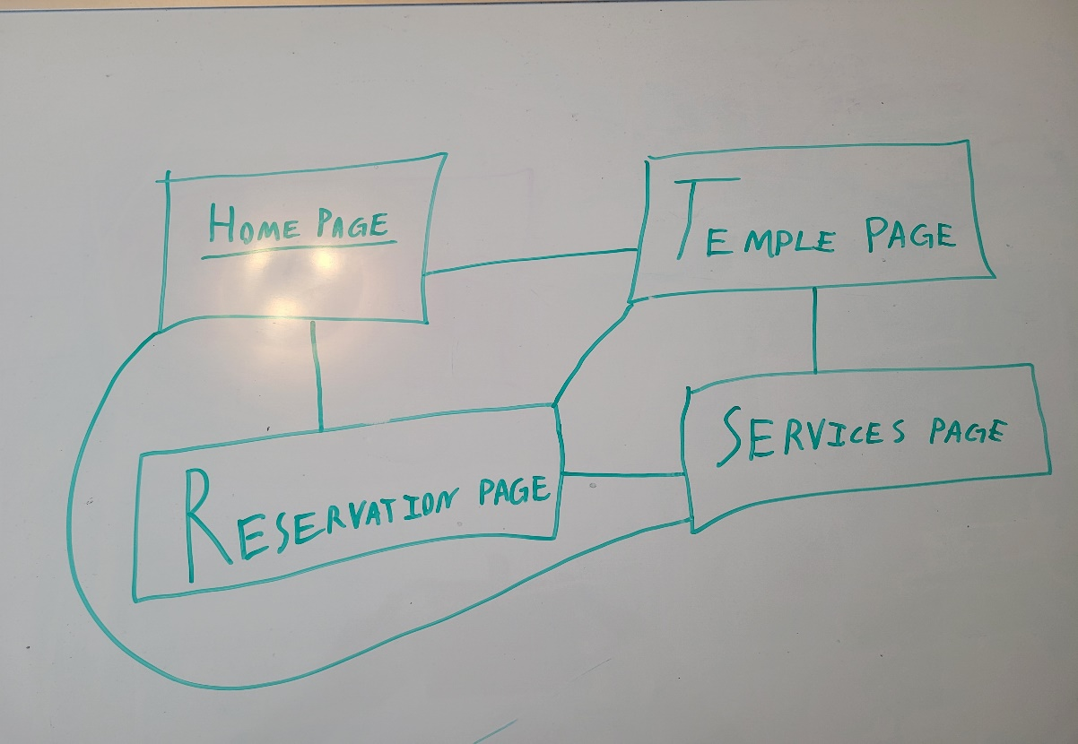

**Color Scheme:**

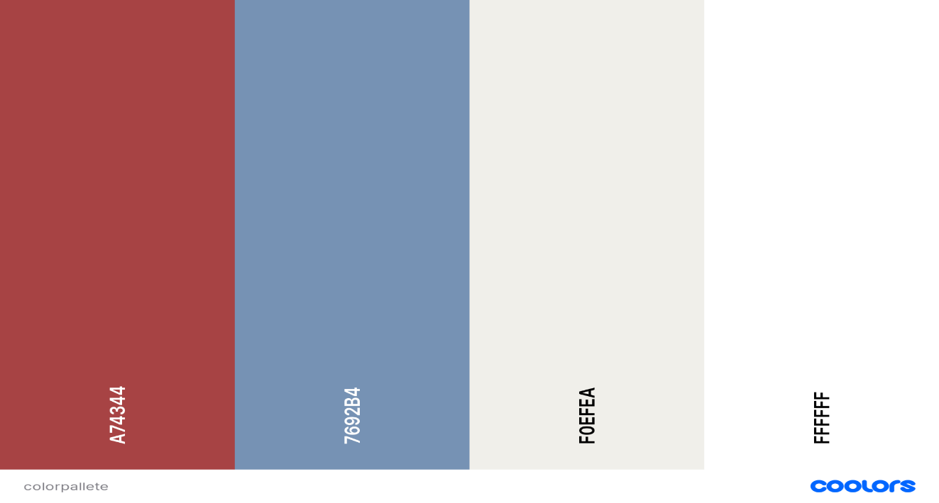

**Logo:**



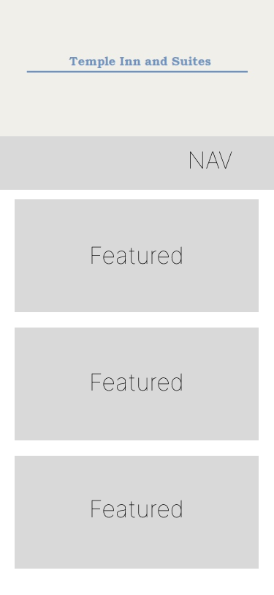**Wireframe Sketches:**

